PRF versus Ozone versus Ozone+PRF for chronic shoulder pain

Statistical Analysis
Statistical analysis was done by Prof MSE Easy Stat v1.0. Shapiro-Wilk test and histograms were used to evaluate the normality of the distribution of data. Quantitative parametric data were presented as mean and standard deviation (SD) and were analyzed by ANOVA (F) test with post hoc test (Tukey). Quantitative non-parametric data were presented as median and interquartile range (IQR) and were analyzed by Kruskal-Wallis test with Mann-Whitney test to compare each two groups. Qualitative variables were presented as frequency and percentage (%) and were analyzed utilizing the Chi-square test. Effect estimates were reported as mean differences (Tukey-adjusted), Hodges-Lehmann median differences and relative risks (RR) with 95% confidence intervals (CI). Changes over time within each group were assessed using repeated-measures ANOVA with Greenhouse-Geisser correction for parametric data and Friedman test for non-parametric data. A two tailed P value ≤ 0.05 was considered statistically significant.

Results
In this study, 76 patients were assessed for eligibility; 16 patients were excluded (not meeting inclusion criteria: 11; declined to participate: 5). The remaining 60 patients were randomly allocated into three equal groups (20 patients in each). All allocated patients were followed up and analyzed statistically.
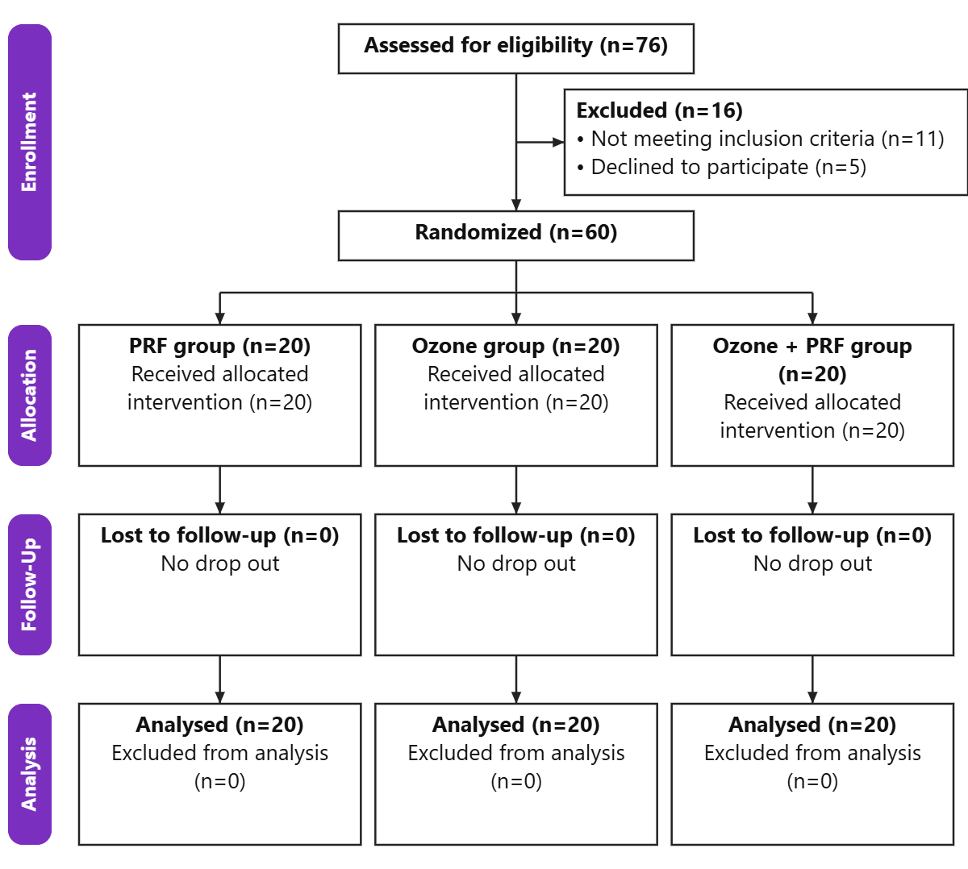
Figure 1: CONSORT flowchart of the enrolled patients
Table 1: Demographic and baseline data of the studied groups
 |  | PRF group (n=20) | Ozone group (n=20) | Ozone + PRF group (n=20) | P value | MD/RR (95% CI)
Age (years) | Mean ± SD | 49.2 ± 8.06 | 51.9 ± 9.06 | 45.75 ± 9.24 | 0.095 | M1=-2.7 (-9.4:4)  M2=3.45 (-3.25:10.15)  M3=6.15 (-0.55:12.85)
Age (years) | Range | 36 - 65 | 35 - 65 | 24 - 61 | 0.095
Sex | Male | 9 (45%) | 7 (35%) | 7 (35%) | 0.754 | RR1: 1.29 (0.6-2.77)  RR2: 1.29 (0.6-2.77)  RR3: 1 (0.43-2.33)
Sex | Female | 11 (55%) | 13 (65%) | 13 (65%) | 0.754
Affected side | Right | 7 (35%) | 9 (45%) | 10 (50%) | 0.622 | RR1: 0.78 (0.36-1.68)  RR2: 0.7 (0.33-1.47)  RR3: 0.9 (0.47-1.73)
Affected side | Left | 13 (65%) | 11 (55%) | 10 (50%) | 0.622
Pain duration (months) | Median | 13.6 | 10.35 | 14.05 | 0.554 | M1=1.05 (-2:6)  M2=0 (-3.5:3.9)  M3=-1.8 (-6.6:2.8)
Pain duration (months) | IQR | 8.3 - 18.68 | 6.1 - 18.55 | 10.95 - 15.83 | 0.554 | M1=1.05 (-2:6)  M2=0 (-3.5:3.9)  M3=-1.8 (-6.6:2.8)
Data are presented as mean ± SD, median (IQR) and frequency (%), MD: Mean or median difference, RR: Relative risk, CI: Confidence interval, M1: between PRF group and Ozone group, M2: between PRF group and Ozone + PRF group, M3: between Ozone group and Ozone + PRF group, RR1: Relative risk between PRF group and Ozone group, RR2: Relative risk between PRF group and Ozone + PRF group, RR3: Relative risk between Ozone group and Ozone + PRF group.
Age, sex, affected side and pain duration were insignificantly different among the three groups.
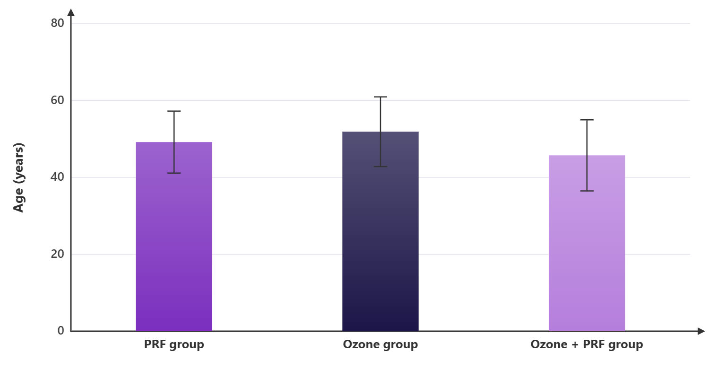
Figure 2: Age (years) of the studied groups
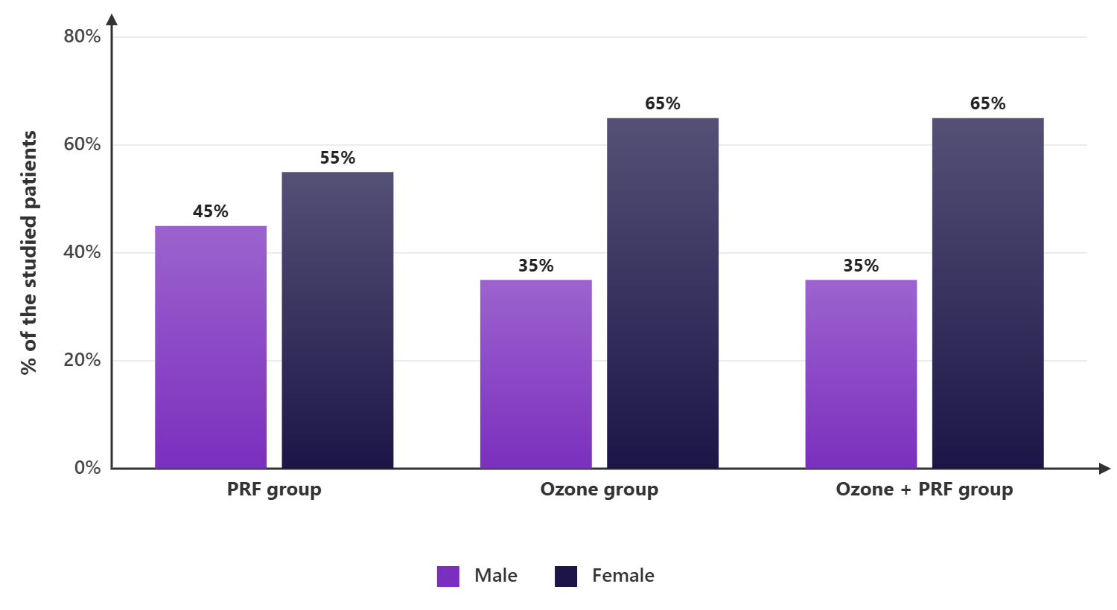
Figure 3: Sex of the studied groups
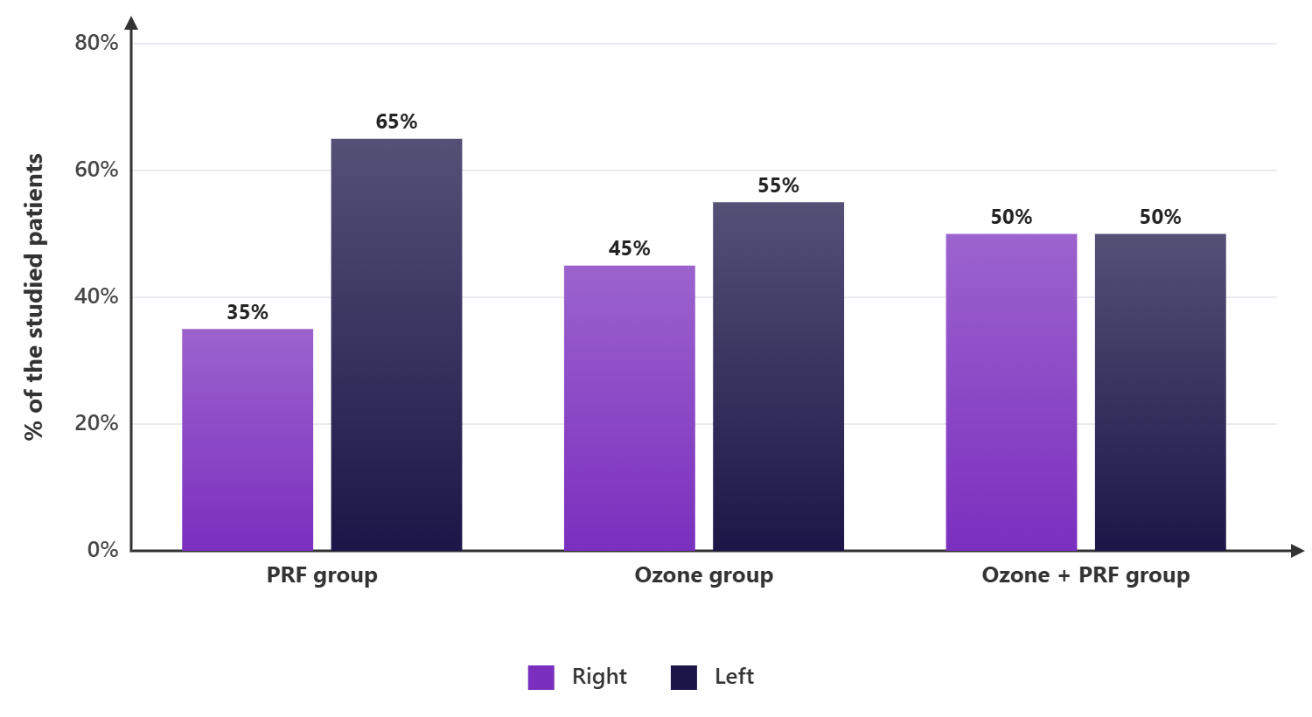
Figure 4: Affected side of the studied groups
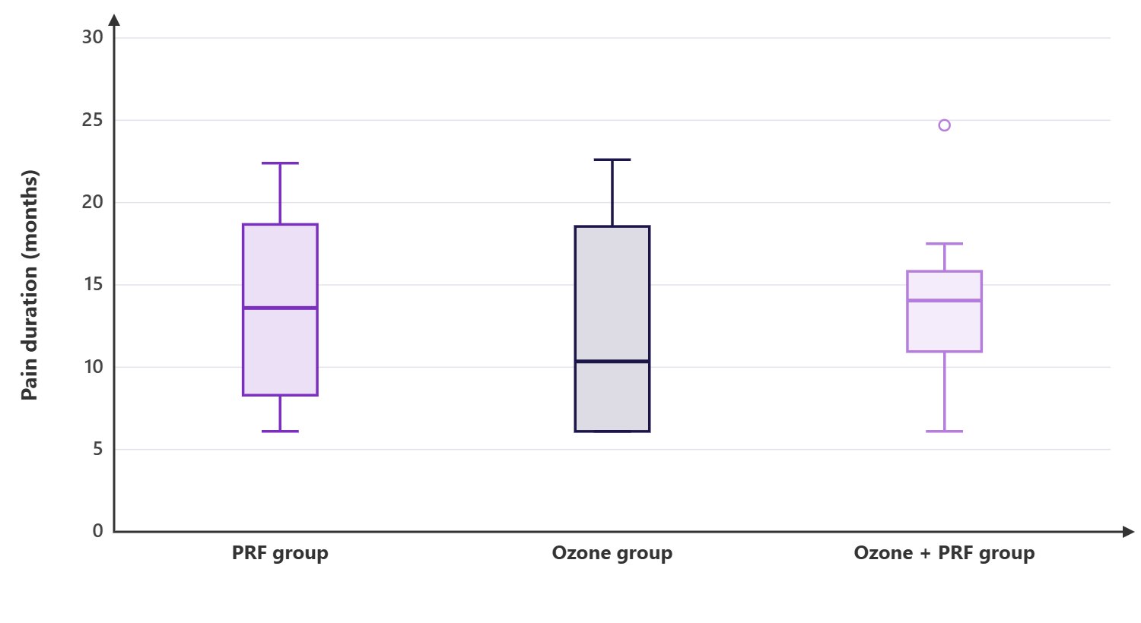
Figure 5: Pain duration (months) of the studied groups
Table 2: NRS at rest of the studied groups
 | PRF group (n=20) | Ozone group (n=20) | Ozone + PRF group (n=20) | P value | Post hoc | MD (95% CI)
Baseline | 6 (5 - 7) | 6 (5.25 - 7) | 6 (6 - 7) | 0.609 | --- | M1=0 (-1:1)  M2=0 (-1:0)  M3=0 (-1:0)
2h | 6 (4 - 6) | 5 (4 - 6) | 5 (4 - 6) | 0.580 | --- | M1=0 (0:1)  M2=0 (-1:2)  M3=0 (-1:1)
W1 | 4 (4 - 5.75) | 5 (4 - 5.75) | 4.5 (3.25 - 5) | 0.714 | --- | M1=0 (-1:1)  M2=0 (-1:1)  M3=0 (-1:1)
W2 | 4.5 (2.25 - 5) | 4 (4 - 5) | 4 (3 - 4) | 0.289 | --- | M1=0 (-1:1)  M2=1 (-1:2)  M3=1 (0:1)
W4 | 4 (3.25 - 5) | 4 (3 - 4) | 3 (2 - 4) | 0.033* | P1=0.505  P2=0.021*  P3=0.036* | M1=0 (0:1)  M2=1 (0:2)  M3=1 (0:1)
W8 | 4 (2 - 5) | 4 (3 - 4) | 3 (2.25 - 5) | 0.998 | --- | M1=0 (-1:1)  M2=0 (-1:1)  M3=0 (-1:1)
P (within group) | <0.001* | <0.001* | <0.001*
*: Significant as P value ≤ 0.05, Data are presented as median (IQR), MD: Median difference, CI: Confidence interval, M1: between PRF group and Ozone group, M2: between PRF group and Ozone + PRF group, M3: between Ozone group and Ozone + PRF group, P1: P value between PRF group and Ozone group, P2: P value between PRF group and Ozone + PRF group, P3: P value between Ozone group and Ozone + PRF group, NRS: Numeric rating scale, W: Weeks.
NRS at rest at (Baseline, 2h, W1, W2 and W8) was insignificantly different among the three groups. NRS at rest at W4 was significantly lower in Ozone + PRF group than (PRF group and Ozone group) (P value = 0.021 and 0.036 respectively) and was insignificantly different between PRF group and Ozone group. Within each group, NRS at rest decreased significantly over time in PRF group, Ozone group and Ozone + PRF group (P value < 0.001 in each).
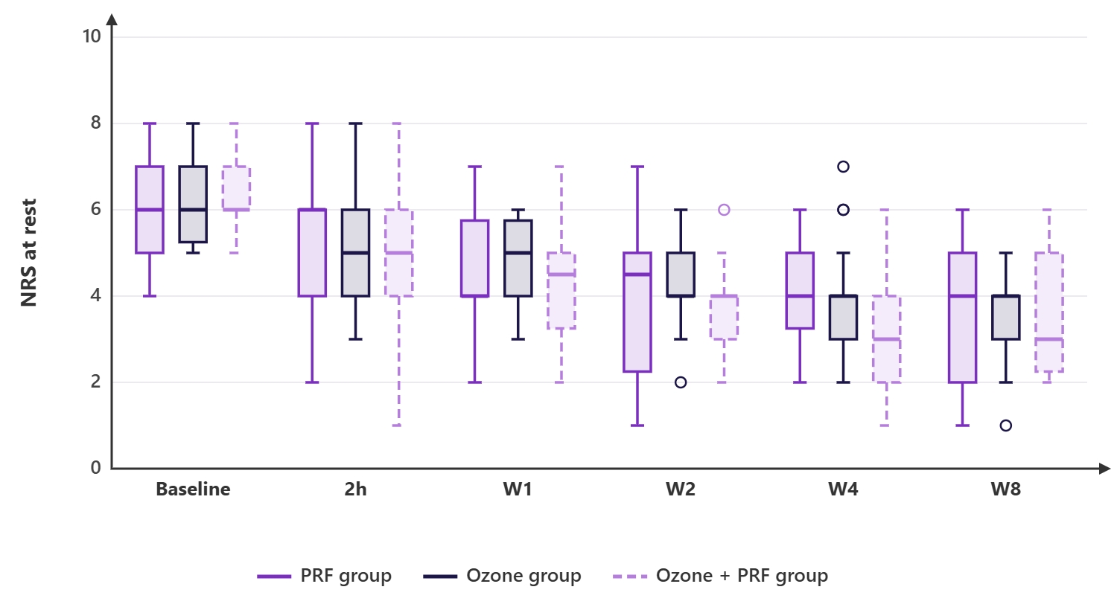
Figure 6: NRS at rest of the studied groups
Table 3: NRS at movement of the studied groups
 | PRF group (n=20) | Ozone group (n=20) | Ozone + PRF group (n=20) | P value | Post hoc | MD (95% CI)
Baseline | 7.5 (7 - 9) | 8 (7 - 9) | 8 (7 - 8) | 0.363 | --- | M1=-1 (-1:0)  M2=0 (-1:1)  M3=0 (0:1)
2h | 7 (5 - 7.75) | 7 (6 - 8) | 6 (6 - 7) | 0.252 | --- | M1=-1 (-1:0)  M2=0 (-1:1)  M3=1 (0:2)
W1 | 6 (5 - 7) | 7 (6 - 8) | 5.5 (5 - 6.75) | 0.037* | P1=0.105  P2=0.398  P3=0.011* | M1=-1 (-2:0)  M2=0 (-1:1)  M3=1 (0:2)
W2 | 6 (4 - 7) | 6 (5 - 7) | 5 (4 - 5.75) | 0.045* | P1=0.433  P2=0.208  P3=0.007* | M1=-1 (-2:1)  M2=1 (0:2)  M3=1 (0:2)
W4 | 6 (4.25 - 7) | 6 (5 - 7) | 5 (3.25 - 5) | 0.005* | P1=0.901  P2=0.014*  P3=0.002* | M1=0 (-1:1)  M2=1 (0:3)  M3=1 (1:2)
W8 | 5.5 (4 - 7) | 5.5 (5 - 6.75) | 4.5 (4 - 6) | 0.301 | --- | M1=0 (-1:1)  M2=0 (-1:2)  M3=1 (0:2)
P (within group) | <0.001* | <0.001* | <0.001*
*: Significant as P value ≤ 0.05, Data are presented as median (IQR), MD: Median difference, CI: Confidence interval, M1: between PRF group and Ozone group, M2: between PRF group and Ozone + PRF group, M3: between Ozone group and Ozone + PRF group, P1: P value between PRF group and Ozone group, P2: P value between PRF group and Ozone + PRF group, P3: P value between Ozone group and Ozone + PRF group, NRS: Numeric rating scale, W: Weeks.
NRS at movement at (Baseline, 2h and W8) was insignificantly different among the three groups. NRS at movement at (W1 and W2) was significantly lower in Ozone + PRF group than Ozone group (P value = 0.011 and 0.007 respectively) and was insignificantly different between PRF group and (Ozone group and Ozone + PRF group). NRS at movement at W4 was significantly lower in Ozone + PRF group than (PRF group and Ozone group) (P value = 0.014 and 0.002 respectively) and was insignificantly different between PRF group and Ozone group. Within each group, NRS at movement decreased significantly over time in PRF group, Ozone group and Ozone + PRF group (P value < 0.001 in each).
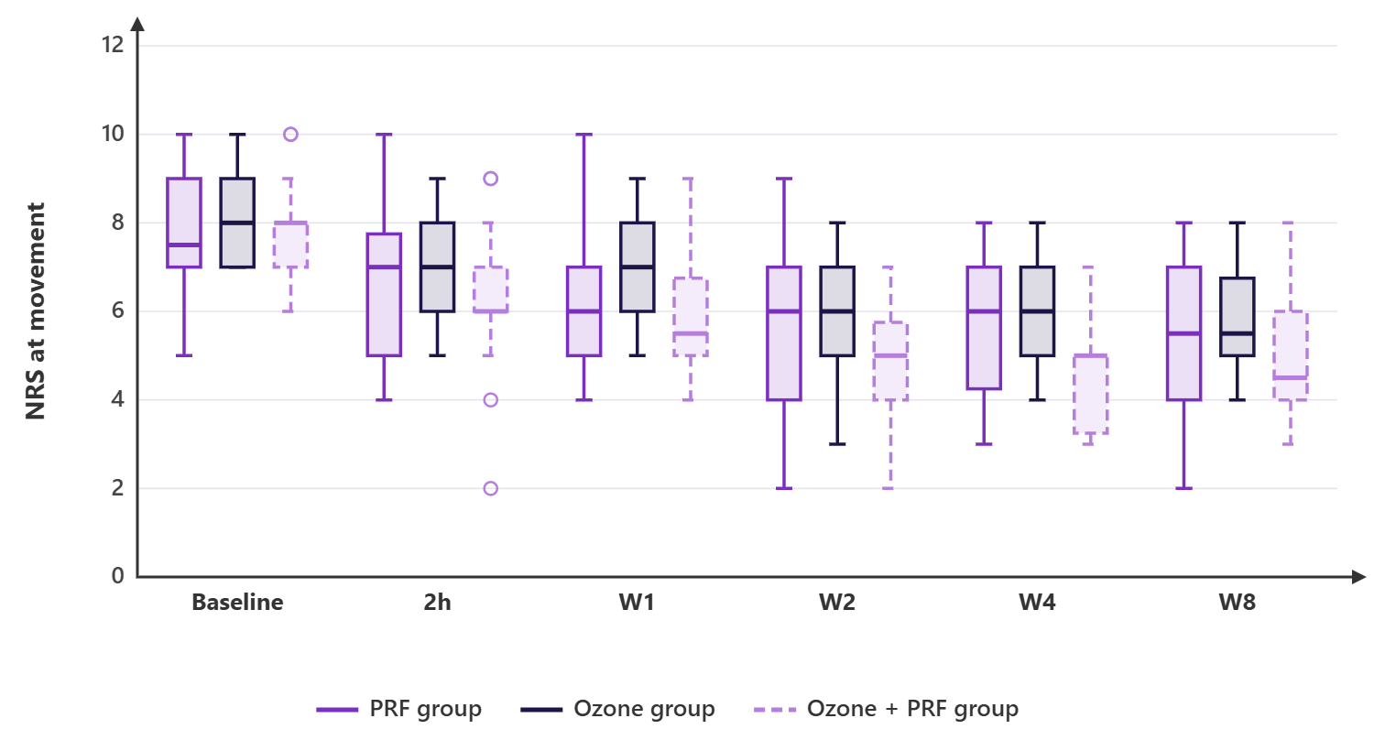
Figure 7: NRS at movement of the studied groups
Table 4: SPADI pain (0-50) of the studied groups
 | PRF group (n=20) | Ozone group (n=20) | Ozone + PRF group (n=20) | P value | MD (95% CI)
Baseline | 31.3 ± 6.38 | 30.75 ± 7.35 | 31.75 ± 7.05 | 0.901 | M1=0.55 (-4.73:5.83)  M2=-0.45 (-5.73:4.83)  M3=-1 (-6.28:4.28)
2h | 28.65 ± 6.76 | 28.65 ± 7.53 | 29.45 ± 6.99 | 0.919 | M1=0 (-5.4:5.4)  M2=-0.8 (-6.2:4.6)  M3=-0.8 (-6.2:4.6)
W1 | 28.2 ± 7.27 | 27.85 ± 7.93 | 27.95 ± 7.27 | 0.989 | M1=0.35 (-5.35:6.05)  M2=0.25 (-5.45:5.95)  M3=-0.1 (-5.8:5.6)
W2 | 28.3 ± 6.86 | 26.8 ± 8.61 | 26.2 ± 7.45 | 0.674 | M1=1.5 (-4.34:7.34)  M2=2.1 (-3.74:7.94)  M3=0.6 (-5.24:6.44)
W4 | 26.95 ± 7.22 | 26 ± 8.21 | 26.45 ± 7.61 | 0.927 | M1=0.95 (-4.9:6.8)  M2=0.5 (-5.35:6.35)  M3=-0.45 (-6.3:5.4)
W8 | 25.7 ± 6.71 | 24.75 ± 6.88 | 25.65 ± 6.72 | 0.883 | M1=0.95 (-4.2:6.1)  M2=0.05 (-5.1:5.2)  M3=-0.9 (-6.05:4.25)
P (within group) | <0.001* | <0.001* | <0.001*
*: Significant as P value ≤ 0.05, Data are presented as mean ± SD, MD: Mean difference, CI: Confidence interval, M1: between PRF group and Ozone group, M2: between PRF group and Ozone + PRF group, M3: between Ozone group and Ozone + PRF group, SPADI: Shoulder pain and disability index, W: Weeks.
SPADI pain at all measurements was insignificantly different among the three groups. Within each group, SPADI pain decreased significantly over time in PRF group, Ozone group and Ozone + PRF group (P value < 0.001 in each).
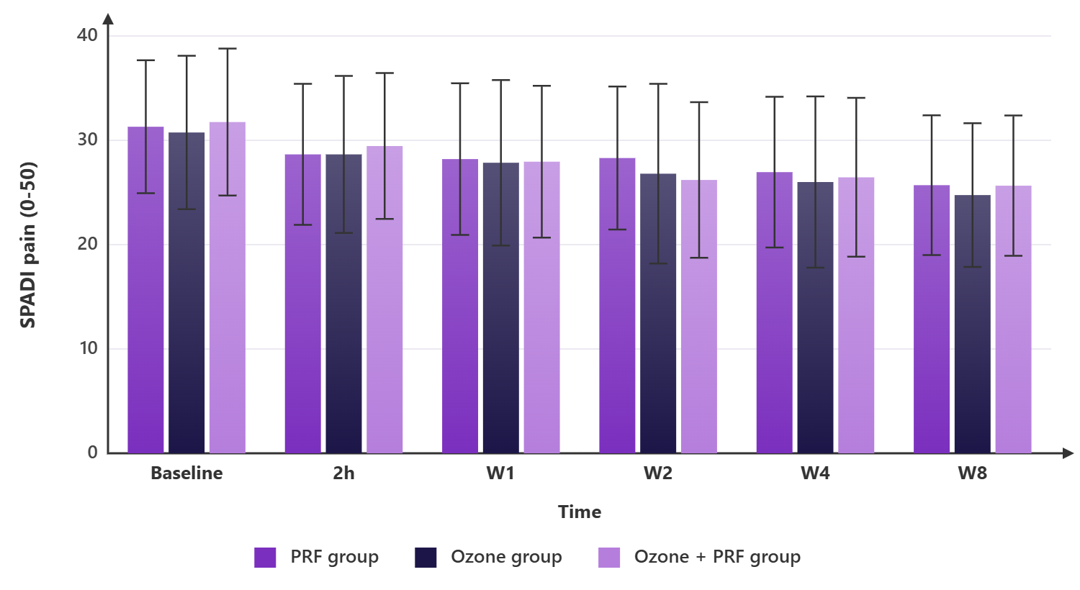
Figure 8: SPADI pain (0-50) of the studied groups
Table 5: SPADI disability (0-80) of the studied groups
 | PRF group (n=20) | Ozone group (n=20) | Ozone + PRF group (n=20) | P value | Post hoc | MD (95% CI)
Baseline | 54.35 ± 11.79 | 47.7 ± 13.93 | 48.3 ± 9.1 | 0.151 | --- | M1=6.65 (-2.31:15.61)  M2=6.05 (-2.91:15.01)  M3=-0.6 (-9.56:8.36)
2h | 50.75 ± 11.16 | 44.65 ± 14.02 | 45.2 ± 9.5 | 0.199 | --- | M1=6.1 (-2.81:15.01)  M2=5.55 (-3.36:14.46)  M3=-0.55 (-9.46:8.36)
W1 | 50.2 ± 10.66 | 43.75 ± 13.84 | 42.9 ± 10.14 | 0.105 | --- | M1=6.45 (-2.42:15.32)  M2=7.3 (-1.57:16.17)  M3=0.85 (-8.02:9.72)
W2 | 50.15 ± 11.8 | 42.1 ± 14.22 | 40.7 ± 9.39 | 0.033* | P1=0.093  P2=0.040*  P3=0.927 | M1=8.05 (-1.06:17.16)  M2=9.45 (0.34:18.56)  M3=1.4 (-7.71:10.51)
W4 | 48.3 ± 11.57 | 41.25 ± 14.33 | 40.8 ± 10.77 | 0.106 | --- | M1=7.05 (-2.32:16.42)  M2=7.5 (-1.87:16.87)  M3=0.45 (-8.92:9.82)
W8 | 46.45 ± 11.88 | 39.2 ± 14.41 | 39.85 ± 9.66 | 0.122 | --- | M1=7.25 (-1.99:16.49)  M2=6.6 (-2.64:15.84)  M3=-0.65 (-9.89:8.59)
P (within group) | <0.001* | <0.001* | <0.001*
*: Significant as P value ≤ 0.05, Data are presented as mean ± SD, MD: Mean difference, CI: Confidence interval, M1: between PRF group and Ozone group, M2: between PRF group and Ozone + PRF group, M3: between Ozone group and Ozone + PRF group, P1: P value between PRF group and Ozone group, P2: P value between PRF group and Ozone + PRF group, P3: P value between Ozone group and Ozone + PRF group, SPADI: Shoulder pain and disability index, W: Weeks.
SPADI disability at (Baseline, 2h, W1, W4 and W8) was insignificantly different among the three groups. SPADI disability at W2 was significantly lower in Ozone + PRF group than PRF group (P value = 0.040) and was insignificantly different between Ozone group and (PRF group and Ozone + PRF group). Within each group, SPADI disability decreased significantly over time in PRF group, Ozone group and Ozone + PRF group (P value < 0.001 in each).
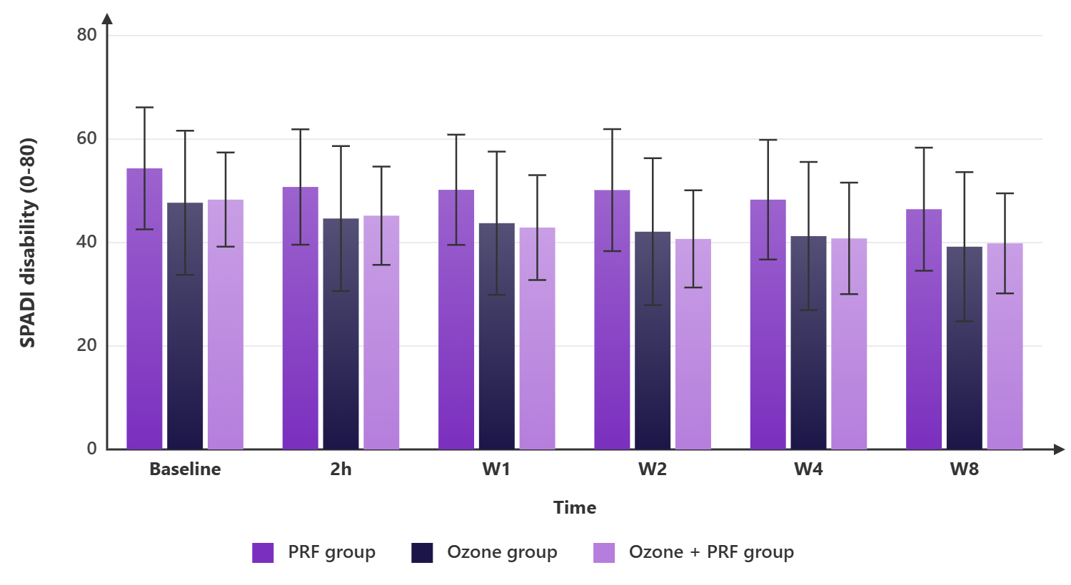
Figure 9: SPADI disability (0-80) of the studied groups
Table 6: SPADI total (0-130) of the studied groups
 | PRF group (n=20) | Ozone group (n=20) | Ozone + PRF group (n=20) | P value | Post hoc | MD (95% CI)
Baseline | 85.65 ± 13.1 | 78.45 ± 15.06 | 80.05 ± 13.25 | 0.233 | --- | M1=7.2 (-3.33:17.73)  M2=5.6 (-4.93:16.13)  M3=-1.6 (-12.13:8.93)
2h | 79.4 ± 12.58 | 73.3 ± 15.19 | 74.65 ± 13.7 | 0.351 | --- | M1=6.1 (-4.45:16.65)  M2=4.75 (-5.8:15.3)  M3=-1.35 (-11.9:9.2)
W1 | 78.4 ± 12.53 | 71.6 ± 15.51 | 70.85 ± 14.78 | 0.194 | --- | M1=6.8 (-4.1:17.7)  M2=7.55 (-3.35:18.45)  M3=0.75 (-10.15:11.65)
W2 | 78.45 ± 13.82 | 68.9 ± 16.95 | 66.9 ± 14.07 | 0.041* | P1=0.119  P2=0.047*  P3=0.907 | M1=9.55 (-1.87:20.97)  M2=11.55 (0.13:22.97)  M3=2 (-9.42:13.42)
W4 | 75.25 ± 13.75 | 67.25 ± 16.72 | 67.25 ± 15.9 | 0.179 | --- | M1=8 (-3.8:19.8)  M2=8 (-3.8:19.8)  M3=0 (-11.8:11.8)
W8 | 72.15 ± 13.5 | 63.95 ± 15.35 | 65.5 ± 13.61 | 0.161 | --- | M1=8.2 (-2.59:18.99)  M2=6.65 (-4.14:17.44)  M3=-1.55 (-12.34:9.24)
P (within group) | <0.001* | <0.001* | <0.001*
*: Significant as P value ≤ 0.05, Data are presented as mean ± SD, MD: Mean difference, CI: Confidence interval, M1: between PRF group and Ozone group, M2: between PRF group and Ozone + PRF group, M3: between Ozone group and Ozone + PRF group, P1: P value between PRF group and Ozone group, P2: P value between PRF group and Ozone + PRF group, P3: P value between Ozone group and Ozone + PRF group, SPADI: Shoulder pain and disability index, W: Weeks.
SPADI total at (Baseline, 2h, W1, W4 and W8) was insignificantly different among the three groups. SPADI total at W2 was significantly lower in Ozone + PRF group than PRF group (P value = 0.047) and was insignificantly different between Ozone group and (PRF group and Ozone + PRF group). Within each group, SPADI total decreased significantly over time in PRF group, Ozone group and Ozone + PRF group (P value < 0.001 in each).
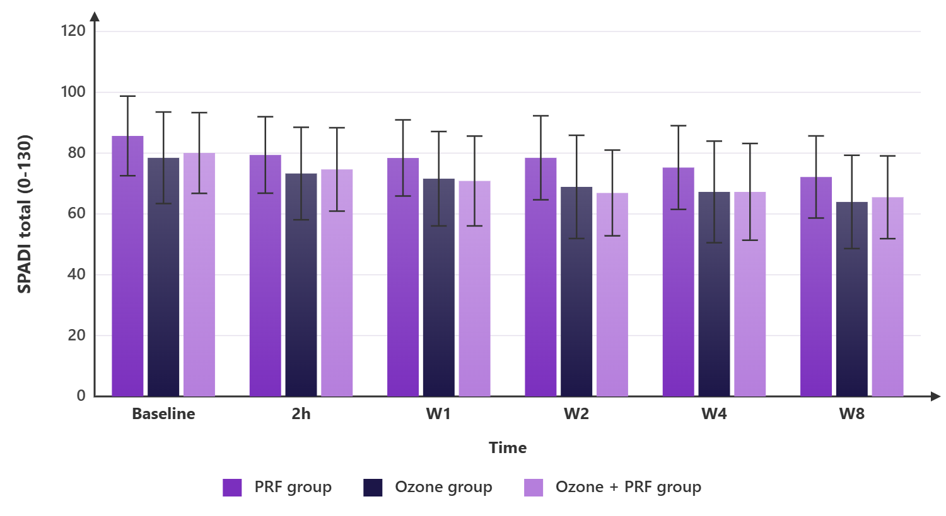
Figure 10: SPADI total (0-130) of the studied groups
Table 7: ROM flexion (deg) of the studied groups
 | PRF group (n=20) | Ozone group (n=20) | Ozone + PRF group (n=20) | P value | MD (95% CI)
Baseline | 114 ± 17.56 | 114.8 ± 19.63 | 111.75 ± 21.49 | 0.878 | M1=-0.8 (-15.73:14.13)  M2=2.25 (-12.68:17.18)  M3=3.05 (-11.88:17.98)
2h | 120.9 ± 18.98 | 118.6 ± 18.51 | 119.2 ± 24.44 | 0.937 | M1=2.3 (-13.54:18.14)  M2=1.7 (-14.14:17.54)  M3=-0.6 (-16.44:15.24)
W1 | 121.8 ± 21.75 | 126.1 ± 22.17 | 122.65 ± 24.5 | 0.820 | M1=-4.3 (-21.68:13.08)  M2=-0.85 (-18.23:16.53)  M3=3.45 (-13.93:20.83)
W2 | 122 ± 18.73 | 124.8 ± 20.75 | 124.4 ± 24.06 | 0.904 | M1=-2.8 (-19:13.4)  M2=-2.4 (-18.6:13.8)  M3=0.4 (-15.8:16.6)
W4 | 124.35 ± 20.91 | 126.15 ± 21.28 | 127.7 ± 19.4 | 0.876 | M1=-1.8 (-17.43:13.83)  M2=-3.35 (-18.98:12.28)  M3=-1.55 (-17.18:14.08)
W8 | 125.65 ± 20.05 | 127.45 ± 20.09 | 126.4 ± 20.47 | 0.961 | M1=-1.8 (-17.17:13.57)  M2=-0.75 (-16.12:14.62)  M3=1.05 (-14.32:16.42)
P (within group) | <0.001* | <0.001* | <0.001*
*: Significant as P value ≤ 0.05, Data are presented as mean ± SD, MD: Mean difference, CI: Confidence interval, M1: between PRF group and Ozone group, M2: between PRF group and Ozone + PRF group, M3: between Ozone group and Ozone + PRF group, ROM: Range of motion, W: Weeks.
ROM flexion at all measurements was insignificantly different among the three groups. Within each group, ROM flexion increased significantly over time in PRF group, Ozone group and Ozone + PRF group (P value < 0.001 in each).
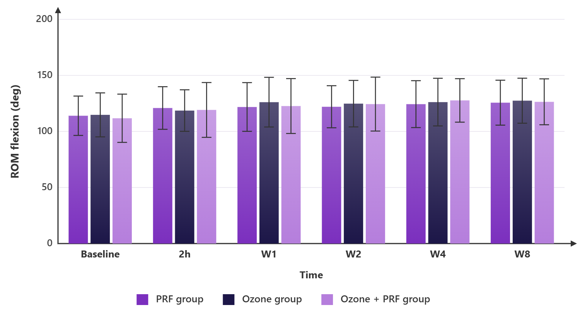
Figure 11: ROM flexion (deg) of the studied groups
Table 8: ROM abduction (deg) of the studied groups
 | PRF group (n=20) | Ozone group (n=20) | Ozone + PRF group (n=20) | P value | MD (95% CI)
Baseline | 109.45 ± 22.68 | 99.65 ± 25.48 | 110.45 ± 21.33 | 0.275 | M1=9.8 (-7.87:27.47)  M2=-1 (-18.67:16.67)  M3=-10.8 (-28.47:6.87)
2h | 115 ± 22.24 | 106.95 ± 32.18 | 118.2 ± 23.13 | 0.383 | M1=8.05 (-11.92:28.02)  M2=-3.2 (-23.17:16.77)  M3=-11.25 (-31.22:8.72)
W1 | 118.05 ± 24.15 | 105.9 ± 27.76 | 119.5 ± 23.33 | 0.181 | M1=12.15 (-6.99:31.29)  M2=-1.45 (-20.59:17.69)  M3=-13.6 (-32.74:5.54)
W2 | 118.85 ± 26.56 | 111.35 ± 28.37 | 120.7 ± 20.38 | 0.471 | M1=7.5 (-11.78:26.78)  M2=-1.85 (-21.13:17.43)  M3=-9.35 (-28.63:9.93)
W4 | 121.3 ± 23.77 | 113.2 ± 28.72 | 125.45 ± 21.85 | 0.295 | M1=8.1 (-10.89:27.09)  M2=-4.15 (-23.14:14.84)  M3=-12.25 (-31.24:6.74)
W8 | 122.3 ± 26.18 | 110.95 ± 28.63 | 125 ± 23.49 | 0.207 | M1=11.35 (-8.57:31.27)  M2=-2.7 (-22.62:17.22)  M3=-14.05 (-33.97:5.87)
P (within group) | <0.001* | <0.001* | <0.001*
*: Significant as P value ≤ 0.05, Data are presented as mean ± SD, MD: Mean difference, CI: Confidence interval, M1: between PRF group and Ozone group, M2: between PRF group and Ozone + PRF group, M3: between Ozone group and Ozone + PRF group, ROM: Range of motion, W: Weeks.
ROM abduction at all measurements was insignificantly different among the three groups. Within each group, ROM abduction increased significantly over time in PRF group, Ozone group and Ozone + PRF group (P value < 0.001 in each).
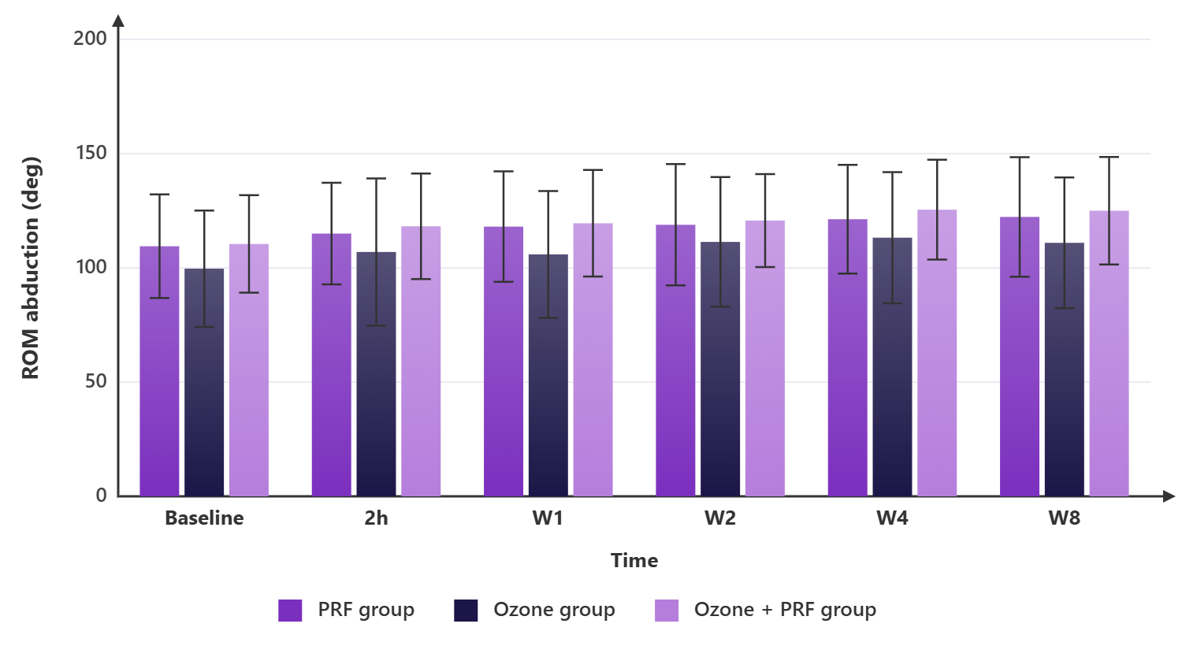
Figure 12: ROM abduction (deg) of the studied groups
Table 9: ROM external rotation (deg) of the studied groups
 | PRF group (n=20) | Ozone group (n=20) | Ozone + PRF group (n=20) | P value | MD (95% CI)
Baseline | 40 ± 9.34 | 36.05 ± 7.74 | 38.8 ± 10.94 | 0.403 | M1=3.95 (-3.23:11.13)  M2=1.2 (-5.98:8.38)  M3=-2.75 (-9.93:4.43)
2h | 40.85 ± 11.15 | 37 ± 8.79 | 40.5 ± 12 | 0.460 | M1=3.85 (-4.32:12.02)  M2=0.35 (-7.82:8.52)  M3=-3.5 (-11.67:4.67)
W1 | 42.2 ± 9.58 | 38.4 ± 9.99 | 45.1 ± 12.98 | 0.162 | M1=3.8 (-4.54:12.14)  M2=-2.9 (-11.24:5.44)  M3=-6.7 (-15.04:1.64)
W2 | 42.7 ± 10.34 | 38.7 ± 9.18 | 42.8 ± 11.24 | 0.362 | M1=4 (-3.83:11.83)  M2=-0.1 (-7.93:7.73)  M3=-4.1 (-11.93:3.73)
W4 | 45 ± 9.57 | 41.5 ± 8.97 | 45.9 ± 10.77 | 0.332 | M1=3.5 (-3.96:10.96)  M2=-0.9 (-8.36:6.56)  M3=-4.4 (-11.86:3.06)
W8 | 44.7 ± 9.67 | 42.05 ± 9.06 | 44.35 ± 11.02 | 0.660 | M1=2.65 (-4.92:10.22)  M2=0.35 (-7.22:7.92)  M3=-2.3 (-9.87:5.27)
P (within group) | <0.001* | <0.001* | <0.001*
*: Significant as P value ≤ 0.05, Data are presented as mean ± SD, MD: Mean difference, CI: Confidence interval, M1: between PRF group and Ozone group, M2: between PRF group and Ozone + PRF group, M3: between Ozone group and Ozone + PRF group, ROM: Range of motion, W: Weeks.
ROM external rotation at all measurements was insignificantly different among the three groups. Within each group, ROM external rotation increased significantly over time in PRF group, Ozone group and Ozone + PRF group (P value < 0.001 in each).
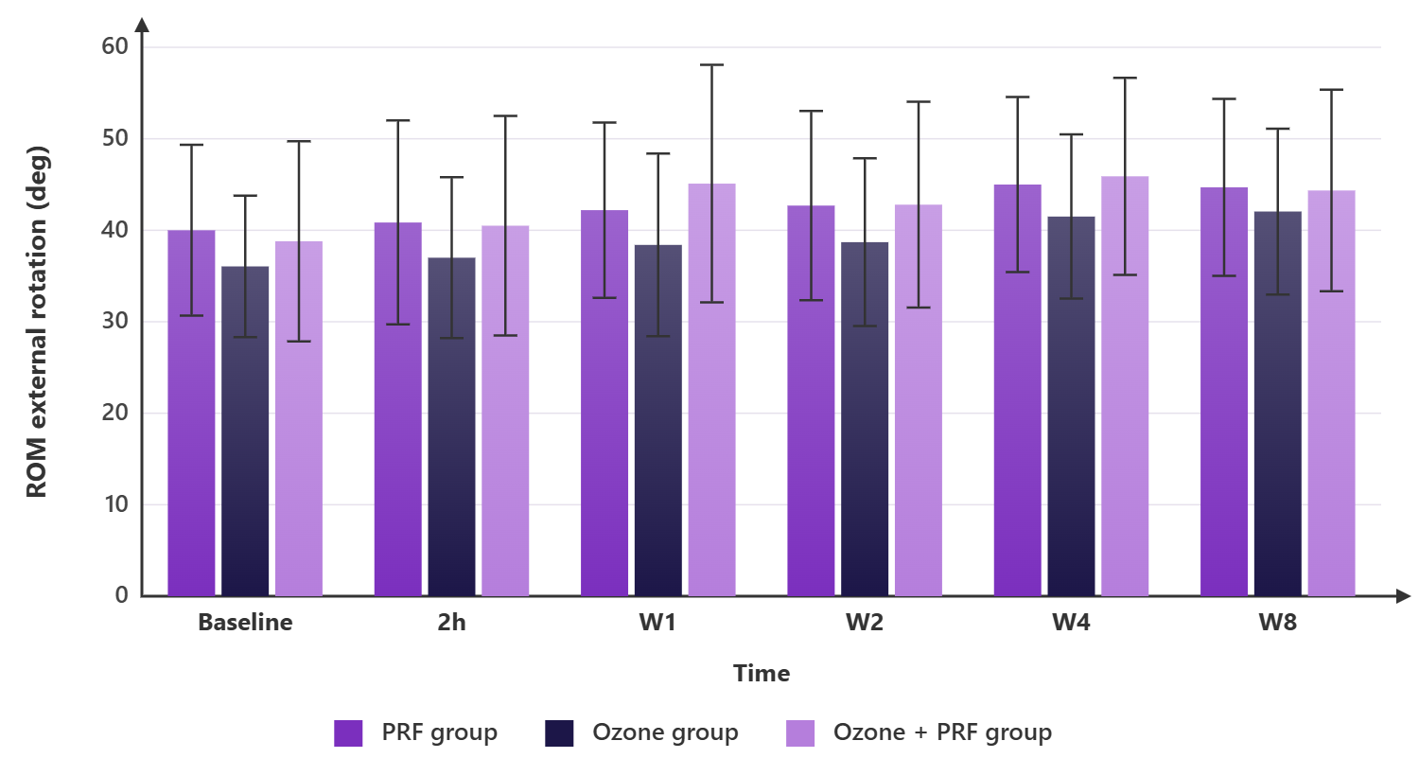
Figure 13: ROM external rotation (deg) of the studied groups
Table 10: Other outcomes of the studied groups
 | PRF group (n=20) | Ozone group (n=20) | Ozone + PRF group (n=20) | P value | RR (95% CI)
Rescue paracetamol used at any follow-up | 7 (35%) | 9 (45%) | 8 (40%) | 0.812 | RR1: 0.78 (0.36-1.68)  RR2: 0.87 (0.39-1.95)  RR3: 1.13 (0.55-2.32)
Any recorded complication | 0 (0%) | 0 (0%) | 4 (20%) | 0.014* | RR1: —  RR2: —  RR3: —
Completed week 8 follow-up | 20 (100%) | 18 (90%) | 19 (95%) | 0.349 | RR1: 1.11 (0.96-1.29)  RR2: 1.05 (0.95-1.16)  RR3: 0.95 (0.79-1.13)
*: Significant as P value ≤ 0.05, Data are presented as frequency (%), RR: Relative risk, CI: Confidence interval, RR1: Relative risk between PRF group and Ozone group, RR2: Relative risk between PRF group and Ozone + PRF group, RR3: Relative risk between Ozone group and Ozone + PRF group.
Rescue paracetamol used at any follow-up and completed week 8 follow-up were insignificantly different among the three groups. Any recorded complication was significantly different among the three groups (P value = 0.014), being highest in Ozone + PRF group (20%).
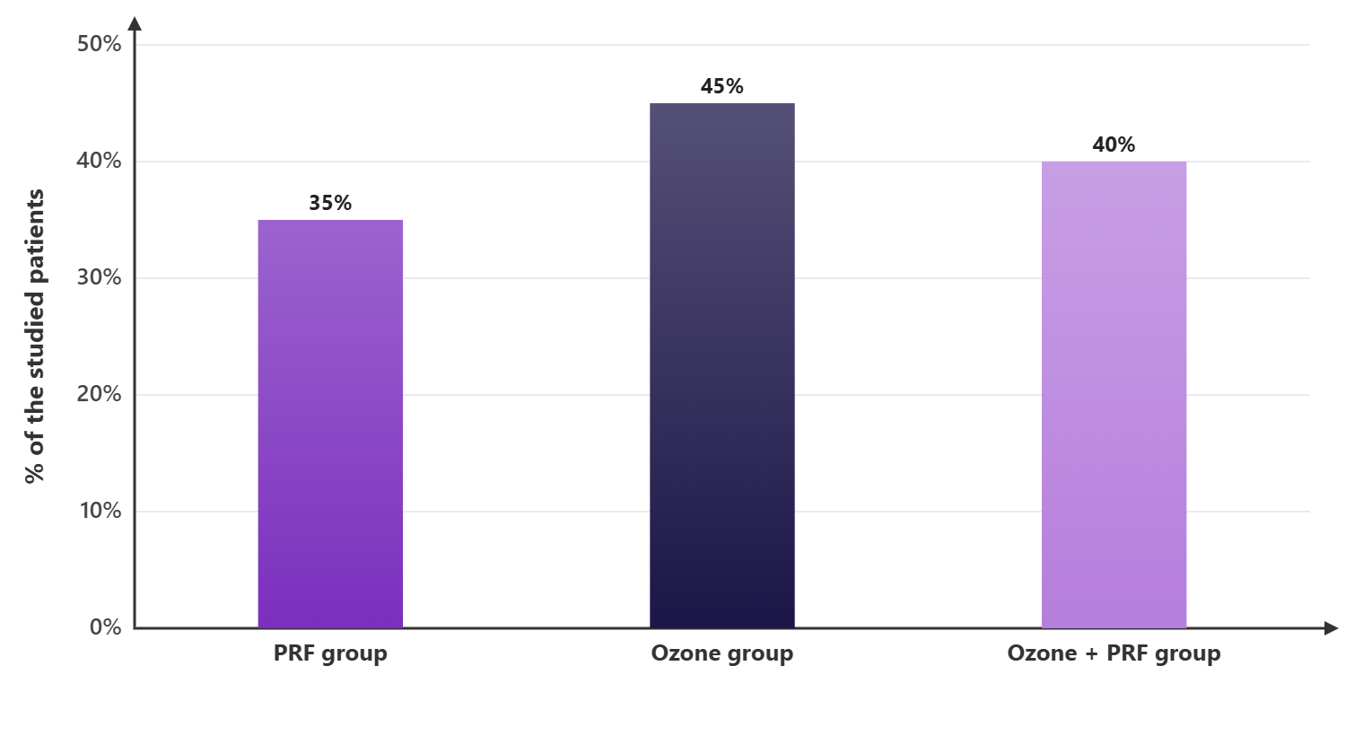
Figure 14: Rescue paracetamol used at any follow-up of the studied groups
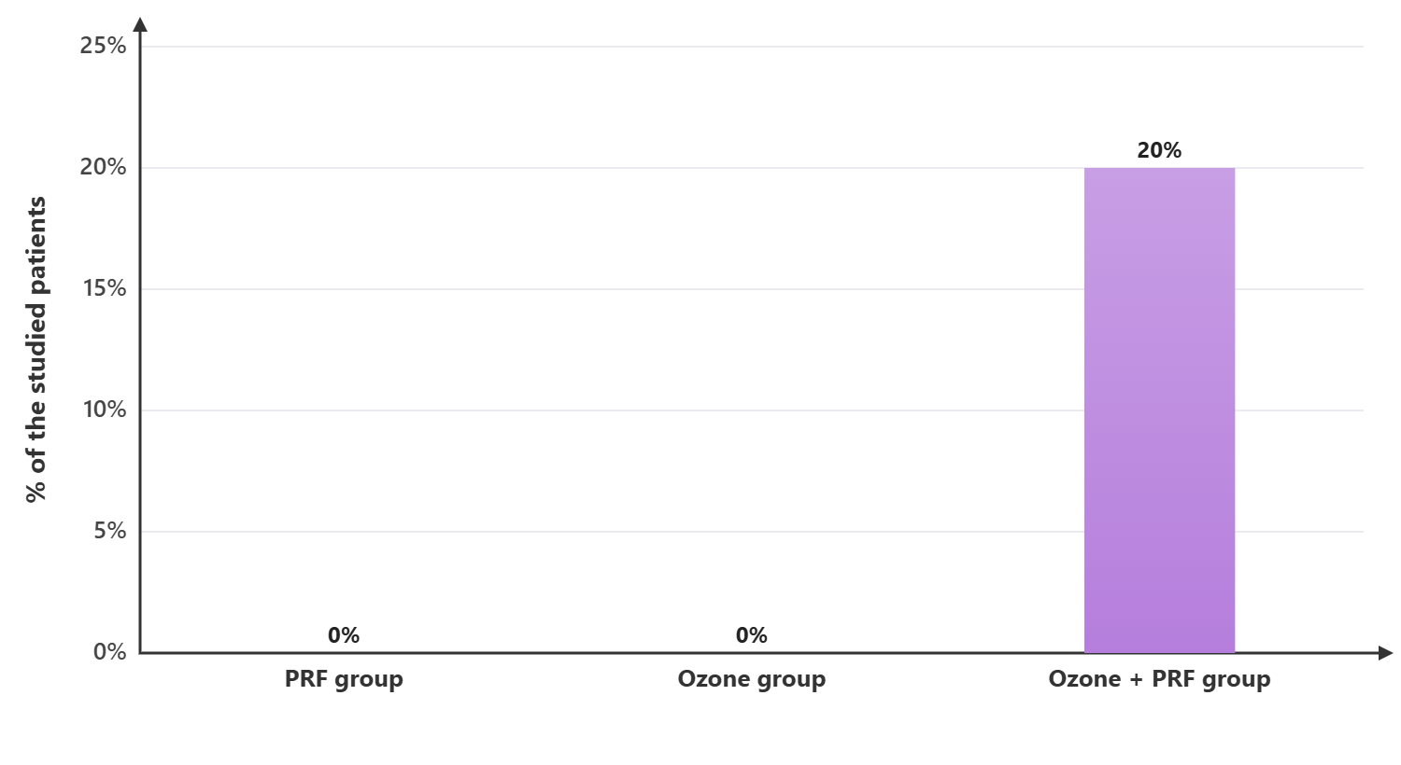
Figure 15: Any recorded complication of the studied groups
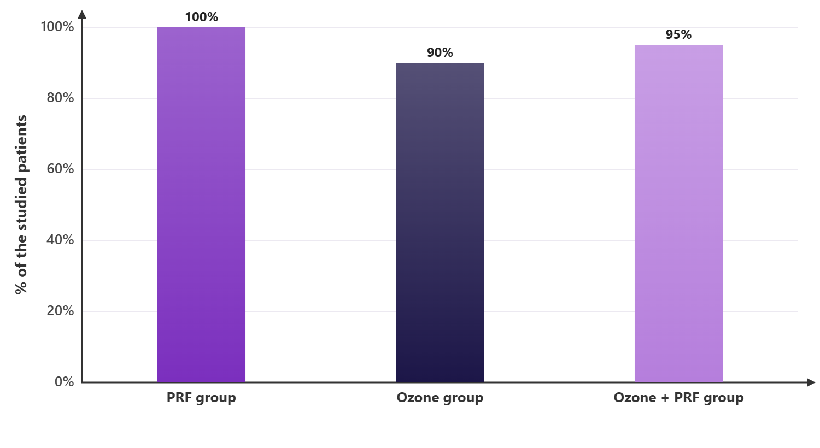
Figure 16: Completed week 8 follow-up of the studied groups

